Project 2: CS/CE/SE 3345: Data Structures and Algorithm Analysis

Purpose: Sorting Techniques Due Date: March 31 at 11:30pm

**The purpose of this assignment is to implement various data structures and algorithms described in class.**

Overview

One of the most important ADTs is the Dictionary and one of the most studied problems is sorting. In this assignment, you will write multiple implementations of sorting algorithms.

Are there techniques you can create or tweaks you can make to introduce a Winning Algorithm for this assignment outside of the techniques listed in the GUI?

Write program GUI or non-GUI to perform analysis on various sorting algorithms from the Sorting Algorithm Slides. Submit a report discussing the analysis at each iteration. Clearly define your approach, challenge and assessment.

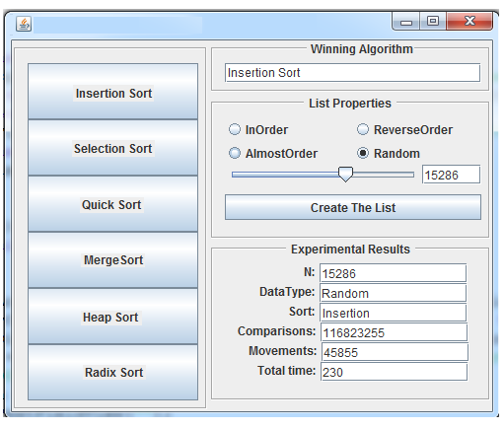

|  |  |  |  |  |  |  |  |  |
| --- | --- | --- | --- | --- | --- | --- | --- | --- |
| Experimental Results | InOrder | ReverseOrder | AlmostOrder | Random | Array Size | Comparisons | Movements | Total Time |
| Insetion Sort |  |  |  |  |  |  |  |  |
| Selection Sort |  |  |  |  |  |  |  |  |
| Quick Sort |  |  |  |  |  |  |  |  |
| Merge Sort |  |  |  |  |  |  |  |  |
| Heap Radix Sort |  |  |  |  |  |  |  |  |